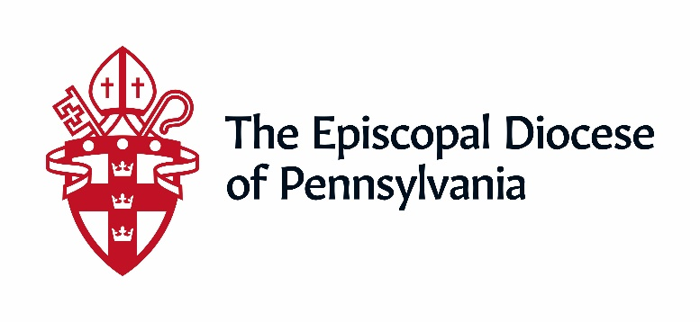

The Diocese of Pennsylvania Technology Grants are designed to equip our churches with the tools to provide pre-recorded and/or streaming of their services and ministries. These grants of up to $5,000 per church can be used to bring Internet into a space; or acquire/upgrade equipment used for virtual worship (cameras, lighting, microphones, software, etc.). The diocese continues to provide free technology consultation to churches – in person or online – as needed through our Digital Disciples program and Media Center.

If you wish to apply for a Technology Grant please answer the following questions, using additional pages if necessary, and provide the following documentation as appropriate. Your responses and attachments should be sent to dhorner@diopa.org with “tech grants” in the subject header.

1. The church’s name and address.
2. The name and contact information for a designated point person.
3. Description of the project:
- Will your church need support in selecting needed equipment and/or technology that best fits your needs? If you are unsure what is available or what is needed, please contact us at jenbtucker@diopa.org. We are here to help.
- Will the grant be used for access to internet, technology and equipment? How much will/did it cost?
- What is an approximate breakdown of how the fund will be spent: Labor, materials, etc? What is the timeline for its completion?
- Will you need advice, training or support from one of our digital disciples on how to use the equipment or technology purchased?
4. A copy of the following:
- Minutes of the Vestry meeting indicating approval of the proposed project
- If applying the grant to a completed project, invoices of equipment purchased or work done.

Please, submit all materials to Canon Doug Horner at dhorner@diopa.org. Applications will be forwarded to the special committee appointed to review and approve awards.

