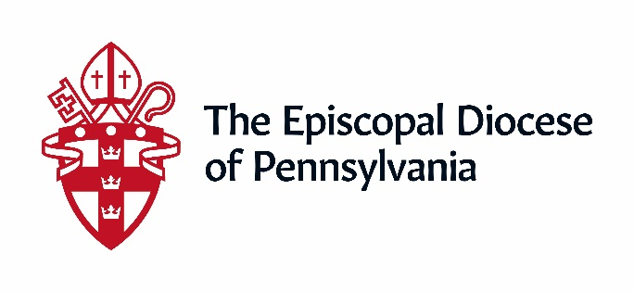
The Standing Committee is a body of advice and consent, working with the Diocesan Bishop, and is involved in making strategic decisions for both the Episcopal Diocese of Pennsylvania and The Episcopal Church in raising up, calling and/or approving the call of candidates for ordination and the Episcopate. Candidates for the Committee have:
- Expertise and/or experience with financial, legal (canonical), real estate, and/or property oversight
- Working knowledge of diocesan and the Canons of the Episcopal Church
- Prior experience on a vestry, diocesan committee, or work with The Episcopal Church
- And, are committed to an average of approximately eight-ten hours per month.
Serving on the Standing Committee is an honor, but also requires a considerable time commitment. It is suggested that serving on the Standing Committee be your only diocesan commitment.
Roles and Responsibilities of the Standing Committee
Acts as the Bishop’s Council of Advice
- Serves as the Ecclesiastical Authority in the absence of a Bishop
- Can call a Special Convention
- Can organize themselves by making rules of meetings and business
- Provides advice and consent for the Bishop’s appointment of Treasure and Assistant Treasurer
- Provide advice and consent for the Bishop’s appointment of Chancellor and Vice-Chancellor
- Advise the Bishop on matters of removing, taking down, or deconsecrating and consecrating church or chapel
- Approving the “alienation or encumbering” of real or personal property of churches
- Give consent of admission to postulancy and ordination to Holy Orders
- Give Consent of applications of formation of new parishes
- Approve the assessment upon parishes, missions and chapels of the Diocese as directed by the Diocesan Convention
- Approve any power of revocation and/or right of withdrawal trust or permanent fund in certain circumstances
- Part of the process to admit Parishes heretofore incorporated
- Review and make recommendations to the draft budget
- Fill vacancies on the Board of Trustees of the Christmas Fund
- Provide a Trustee for Corporations Unable to Function
- Confirm the Bishop’s nominees for vacancies on the Commission of Ministry
- Appoint Secretary and/or Assistant Secretary of Convention in the event of vacancy during recess
- Appoint a Church Attorney to serve until the next meeting of Convention, in the event of the death or resignation of the Church Attorney when the Convention is not in session

