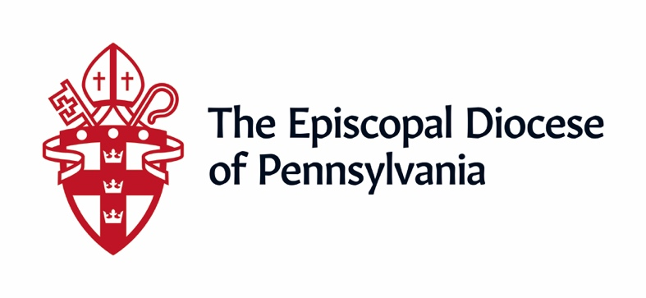

Addendum from 9/10: Lowering the Age for Youth Activity in Phase III
Given that many of our youth are learning from home and are in need of fellowship and support, the Bishop has lowered the age for in-person activity to 13. We have adjusted our documents online to reflect this. All other Phase III protocols for children and youth remain in effect. Should you have any questions please contact Canon Shawn Wamsley (swamsley@diopa.org) or Canon Kirk Berlenbach (kberlenbach@diopa.org).

Protocols for Phase III (Green)

“But those who wait for the Lord shall renew their strength, they shall mount up with wings like eagles, they shall run and not be weary, they shall walk and not faint.” Isaiah 40:31

My Siblings in Christ,

As you have heard, the five counties of our diocese have recently, or will shortly, enter Phase III (Green). Far from marking the conclusion of the process, this is but another step on our journey, a journey of re-entry and a journey of faith.

As I have said before, Phase III is not the lifting of all restrictions. Rather it is the next step of recovery and as such, keeps many of the previous precautions in place. As mentioned in my letter of June 19, in our diocese it was originally referred to as “Phase Two Plus” (Plan for Return pg. 9). To avoid further confusion, we have updated the phases in our Plan so that they are aligned with the Governor’s. The updated document is now posted online and includes the current version of the Governor’s plan and the county-by-county phased map.

Before I proceed, I must emphasize that the pandemic is not over. We are still in the first wave of the virus and a second way is still very much possible. Should the number of cases climb, I will not hesitate to put a halt to in-person activity and return our churches to the Red Phase.

As you continue to discern what re-entry looks like in your church please remember that until we have widespread testing, tracing, treatment, and the vaccine, the safest option is always not to gather. Therefore, clergy and vestry should continue to cautiously and carefully weigh their options and not rush to lift any restrictions until they truly feel both called and fully prepared to do so. Center yourselves in Jesus’ commandment to love one another. Ask yourselves, can we do this without putting someone at risk? Take what you have learned so far about your parishioners and community and integrate it into your planning. As before, any decisions to move from Phase II to Phase III must be reviewed and agreed upon by both the vestry and clergy.

Date for Green
After careful consideration and due to the rise in cases elsewhere, I have determined that our churches may enter the Green Phase on August 1. This is consistent with how we handled the Yellow Phase. It also allows sufficient time to experience worship and operations in Phase II before anyone considers expanding. If the number of cases has not declined sufficiently or we are otherwise not comfortable in reducing restrictions, the Yellow Phase will be extended.
When we enter the Green Phase, the following protocols will be used.

Attendance
Parishes can hold worship or other events at up to 50% of the building or room’s capacity. However, 6 feet physical distancing guidelines must be followed which may further reduce maximum attendance. No matter how large the space, a gathering cannot exceed 250 people. In determining your own capacity please bear in mind that more people equates to more risk and that there must also be adequate plans for ingress, egress and access to bathrooms as well as the capability to clean them more often.

Singing
Because of its high risk, all congregational singing is still prohibited. Soloists and section leaders can reduce distancing from 30 feet to 27 feet. Provided there is sufficient room, a church may have up to 4 soloists/section leaders present. These rules apply to both indoor and outdoor worship.

Fellowship
Masks and distancing must be maintained regardless of location. Food and drink may be permitted as follows:
- People may bring their own food and beverages from home but may not share beyond their immediate household.
- If a church can ensure that people maintain distancing and establish a system which assures that people touch only the object(s) that they will take, then pre-packaged food and beverages may also be served. This can be extremely challenging as people often sort through their options touching multiple items before choosing one.
- Communal items like coffee pots, pitchers of water, trays of food as well as homemade items (even if individually wrapped) may not be offered.

Children and Youth
Because of their difficulty in observing physical distancing, in-person activities for children and youth are still strongly discouraged. Intergenerational activities are permitted without additional conditions provided that the child/youth is accompanied by an adult family member who remains with them throughout the event.

If a church is willing to assume the additional liability, in-person activity for youth 14 and older may resume under the following circumstances:
- They first procure the informed consent of the parent/guardian for the youth to participate.
- They increase the number of adults present to help ensure that all health protocols are observed.

Baptism
It is still preferable to postpone until all restrictions are lifted. According to our rubrics, the next appropriate date for baptism is All Saints Day. If there is a compelling reason, baptisms may be allowed under the following circumstances:
- Only the baptismal party should come to the font.
- All parties should be masked (except for children under 2) and maintain distancing (except for those from a single household).
- Small children and infants should be held by their parent or godparent for the duration of the rite.
- Administration of the water should take place at as great a distance as possible.
- To administer the chrism, the clergy person should keep as much distance as possible and sanitize their hands (with either soap and water or sanitizer) immediately before and after chrismation.
- After the service the font should be emptied and the water properly disposed of.

Episcopal Visitation
It is not yet known when Episcopal Visitations will resume or under what conditions. We are currently studying the matter and will share more details as soon as possible.

All other protocols and guidelines from Phase II including participant temperature checks, contact tracing, communion in one kind and cleaning requirements remain in effect. In addition:
- Everyone must still follow CDC guidelines including use of masks, avoidance of physical contact, use of handwashing and sanitizer, etc.
- Whenever possible, church employees should continue to work from home.
- Whenever possible, it is recommended that meetings be held virtually.
- While more people will be allowed to attend in-person worship, it is strongly recommended that you also continue offering worship via streaming or recording to accommodate those who do not yet feel safe.

Non-Church Groups
As we did for Phase II, non-church groups such as AA, etc., do not have to wait until August 1 but may move to increased gathering sizes when the county transitions to Phase III subject to the same rules for occupancy. However, the church is not in any way required to allow this. The church should base their decision on coordination with the non-parish group, factoring in how well the group in question has been adhering to the Phase II protocols. If the group has been struggling to maintain distance, etc. the church should carefully consider this before allowing them to expand their activity.

Communicating Your Plan to the Bishop
When a church discerns that it is called to move into Phase III, they should inform the Bishop via email. They do not need to submit a detailed plan unless they have not done so previously. They simply need to declare their intent and list what changes they will be making from their Phase II practices. Please be sure to copy Canon Wamsley (swamsley@diopa.or) and Canon Berlenbach (kberlenbach@diopa.org) when you do.

Our re-entry is an ongoing process. We will continue to carefully study all available public health data and expert medical advice. If new and definitive information becomes available that would lead us to adjust these protocols, we will. It is also critical to understand that many areas of the country that rushed into re-opening are seeing spikes in the number of cases. It is not an exaggeration to say that your decisions have life or death ramifications. For the common good, we must proceed with the utmost caution.

Above all else remember who we are and why we exist. As followers of Jesus Christ, we do not make our decisions out of expediency but out of love. As we consider next steps, we must always come back to this core of sacrificial love. Sometimes the most important action we can take is to wait. We have been patient and if we continue to wait upon the Lord, we will continue to discover new and wonderful opportunities to make the love of Jesus known.

Jesus makes all things new and even now he is remaking our lives, our churches, our communities and our world. Let us not pass up this sacred opportunity to demonstrate that there is a better way. We are not called to be like the world. As the Church we are not transactional but incarnational. May every choice we make and every action we take embody the love of Christ so that together we can transform our world.

