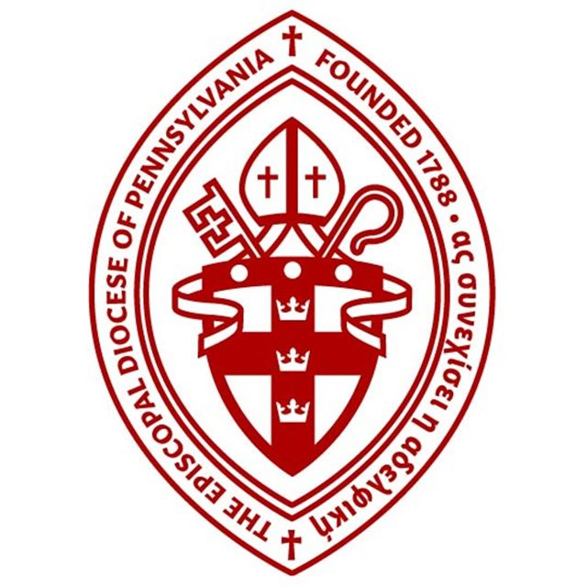

Diocese of Pennsylvania
Finance Committee Meeting
Minutes 12/6/18

Location- St. Asaph’s Church, Bala Cynwyd

Attendees
Ms. Dana Hall, Chair | Canon Doug Horner | Mr. James Pope
Mr. Chris Gadsden | Rev. Sarah Hedgis | Rev. George Master
Mr. Kirk Muller | Rev. Matthew Dayton-Welch | Mr. Christopher Hart
Mr. Eric Rabe | Rev. Peter Carey | Mr. Phillip Anspach
Rev. Joseph Wolyniak | Mr. Sean McCauley | Ms. Takiyah Cuyler
Canon Shawn Wamsley | Mr. Thomas Helm

Minutes

Dana Hall called the meeting to order at 6:30PM.

Dana asked the group to meditate on the funeral and speeches of Former President George H.W. Bush. concept of CAVU (Ceiling and visibility unlimited) recounted by several of the eulogists and the homily at the funeral of Episcopalian, President G H W Bush the day before, in the context of a report from the Episcopal Church in CT on the outlook for staffing and maintaining parishes. Do we risk appearing disconnected from the Convention’s on-the-ground experience when we proclaim a message of expected growth and confidence in Kingdom building. The group discussed long standing challenges to the church and why we are facing challenging times.

Rev. Peter Carey said a prayer for the group.
Treasurer James Pope welcomed new members Rev. Joseph Wolyniak and Phillip Anspach. The group introduced themselves to the new members.

Rev. George Master and Sean McCauley provided a report for the Property Committee

Redeemer Bryn Mawr, is requesting permission to secure either a loan or line of credit for $2.9MM. Documentation was provided. Christopher Hart made a motion to make the recommendation to the standing committee. James Pope seconded the motion. The committee approved the recommendation.

Trinity Boothwyn has unused classrooms in their undercroft. They have been approached by a pre-school operator to use these for a preschool, and are seeking approval to negotiate with that operator. Eric Rabe made a motion to recommend approval to standing committee. Rev. Sarah Hedgis seconded the motion. The committee approved the recommendation.

St. Mary’s Warwick’s buyer has completed pre-sale due diligence. The items currently being stored in that facility will be moved to St Philip’s, Oreland.

Rev. George Master gave a report on discussion of space needs for Diocesan Offices. The Cathedral Chapter has submitted terms of a possible lease renewal. The ad-hoc committee appointed by the Standing Committee has met and is looking at options including repurposing closed churches, renting space, leasing space and other options. The committee will interview a short list of real estate agents on December 17th.

Dana asked for approval of the consent agenda (approval of the prior meeting’s minutes).
The minutes were approved.

The Church Foundation provided their report. Mr. Chris Gadsden and Mr. Tom Helm provided a review of the annual returns and T. Rowe Price, TCF’s appointed investment advisor.

Canon Wamsley discussed how the next year’s communication will take place. Canon Horner discussed the approach for building out the potential asks for the pledge and assessment or whether it would be one unified request. These items will be discussed at the Sacred Gifts Committee meeting on December 11th. Mr. Kirk Muller requested a distinct approach be presented in the next few months to raise these critical numbers.

Dana Hall asked for reflection on the process and presentation of the budget during the time leading up to and at the 235th Convention. She noted that this year’s process will be in the context of the three-year freeze on church contributions to the Dioceses will have ended and that the concrete initiatives the Bishop introduced in his Convention Address may help us articulate the value of working together on Diocesan ministries. Several excellent suggestions were made to build on the trust established through radical transparency, and the need to address more details resulting from the additional transparency.

Christopher Hart provided a report from the Province III apportionment. The increase will be significant, perhaps close to doubling for 2020 from the 2019 amount of $12,500.

James Pope provided a report on a meeting with Church Insurance Corporation (“CIC”) and the intention that CIC will produce a comprehensive proposal for all parishes and other Diocesan entities by mid- March 2019, three months before the renewal date for policies brokered through Sovereign. The expressed hope is that cover will match or exceed existing cover at a premium cost which will be lower than for the 2018 renewal.

Canon Doug Horner then reviewed the financial reports. He reported that our collections of pledges and assessments are behind both in absolute dollars and as a percentage of assessments and pledges. We are projecting a $250,000 deficit for the full year. A temporary cash advance of $500,000 was taken from The Fund for the Episcopate to bridge a cash flow shortfall until the end of December. Mr Pope commented that such a cash flow gap is unfortunately to be considered normal based on the prior years’ experience..

The next meeting of the Finance Committee will take place on January 18th at 6:30PM at St. Asaph’s Church. All new business items should be submitted to the chair, Dana Hall by January 14th.

