What is a Deacon?

God now calls you to a special ministry of servanthood directly under your bishop. In the name of Jesus Christ, you are to serve all people, particularly the poor, the weak, the sick, and the lonely. From The Ordination Of A Deacon, Book Of Common Prayer.

The diaconate is a full and equal order to the priesthood. We maintain our secular jobs and carry our ministry into our neighborhood and workplace. By carrying our ministry of service into the world we can interpret to the church the needs of the world.

At the end of Sunday worship, a deacon dismisses the people. With this action, the deacon is symbolically leading the people out into the world, in service. We all “Go forth,” in the name of Christ, in peace and love, and in the power of the spirit.

We work with the rector, and directly for the Bishop. You will see us serving liturgically on Sunday mornings, but our focus is providing leadership in parish outreach as well as developing our individual ministries in service. There is much to do and many more deacons are needed.

Bishop Gutierrez has called for sixty new deacons in six years. Are you called to this holy work?
Have you felt the tug of the Holy Spirit?

The first step is to pray in discernment, and to discuss it with your Rector. Pray earnestly for discernment of God’s call to you.

If you would like to know more about the life of a deacon, contact us at archdeacon@diopa.org and we will plan a time together to discuss the formation program and to answer any questions you might have.

Each of you should use whatever gift you have received to serve others, as faithful stewards of God’s grace in its various forms. 1 Peter 4:10

Deacons in the Diocese of Pennsylvania

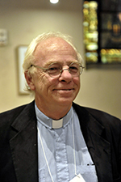
DEACON DENNIS COLEMAN
I serve at St. Peter’s Phoenixville, a parish that is highly involved in Interfaith food ministries. At St. Peter’s we serve about 12000 lunch meals annually hosted by a variety of churches, and provide groceries and a breakfast meal for about 5000 per year. The church also operates as a resource center for housing, medical and spiritual issues, and Bible studies are offered regularly at lunchtime. I am the Chaplain at Good Samaritan Shelter for men in Phoenixville, and work with area support services to assist those on the margins, as well as the truly homeless. At the moment, we are preparing to open a Code Blue center, and a daytime warming/hospitality center at a closed Roman Catholic property. As a board member for “Ann’s Heart” the Roman Catholic church that owns this property. We are working to create a community center. I am a member of the Commission on Ministry for the Diocese.
asdfasdf
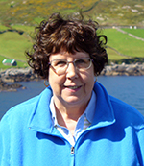
DEACON LYNN CZARNIECKI
I was ordained in 2004 in the Diocese of Newark, and came to the DioPA 2 years ago. I currently serve at Trinity Memorial where I serve in worship, offer pastoral care and participate in various TMC ministries. My primary ministry as deacon is in the field of mental illness. I call my ministry Building Bridges to Hope. Building Bridges to Hope has two arms. The first is spiritual. I have developed a presentation and sermon to give to faith based communities that offers information about mental illness and ways faith based communities can help people with mental illness and their families. I visit churches and other groups to help them explore ways that they can better embrace and care for people with mental illness and their families. The second arm of my ministry involves working as a teacher and support group facilitator for the National Alliance on Mental Illness (NAMI). In this ministry I teach family members about mental illness and facilitate support groups for family members. Acutely aware of how many people with mental illness are without homes or incarcerated, I support and work for programs that also help these populations, such as the Welcome Church.
adsfasdfa
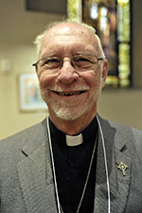
DEACON JOSEPH DIETZ
Deacon Joe Dietz, serving at St. Peter’s, Phoenixville, is active in the pantry ministry to the Phoenixville area. We serve approximately 110 families with groceries every other week throughout the year with special pantry days for Easter, Thanksgiving and Christmas. A breakfast ministry is also provided to our guests before they go to the pantry. Joe also trains and works with the Eucharistic Visitors who share Sunday Eucharist with our homebound, hospitalized and nursing home parishioners. He serves as an alternate with the Commission on Ministry and serves on the Deacons’ Council.

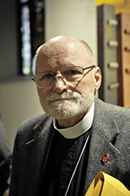
DEACON ROBERT DAVIDSON
Before my current assignment to St. Paul’s, Chestnut Hill, I volunteered to lead a service once a month at the Springfield Retirement Residence which is close to my home. A joint effort by Trinity Church, Ambler and St. Paul’s a team of clergy but mostly lay persons supply a complete service every Sunday afternoon for this facility. Large-print leaflets lead the congregation through the service including hymns and communion from the reserve sacrament. This ministry has grown to three local agencies served in 2015. After receiving training in Pittsburgh from this Lay ministry organization, I revived and recertified a group at St. Paul’s that has been successfully serving clients for three years.
Face-to-Face is a homeless ministry serving the Germantown neighborhood in Philadelphia run by St. Vincent’s Roman Catholic church is supported by contributions from St. Paul’s (among others). On about a monthly basis we send a team of 12 to prepare.
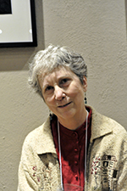
DEACON CAROL DUNCAN
I serve as Deacon at the Church of St. Martin’s in the Field. I am also the co-chair of the Economic Dignity Team of the local faith-based community organizing group POWER (Philadelphians Organized to Witness, Empower and Rebuild). In this role I am helping to craft and roll out our 2016 objectives: 1) to continue to push City Council to legislate a $15 minimum wage for the city; 2) to establish a Philadelphia Public Bank to put the city’s $18 billion to use for the public good instead of paying for it to sit in outside banks; 3) to join the Quakers to get PECO to install solar panels in North Philadelphia and purchase excess power as well as create jobs; 4) to sponsor a 3 day Poverty Summit to hear from all aspects of financial organization and set the social justice agenda for the new city administration.
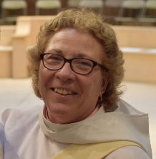
DEACON DIANE E. FAISON
Ordained June 17, 2017. I am serving at Incarnation Holy Sacrament, Drexel Hill with Fr. Ben Wallis and I am currently working with a group of parishioners with Invite*Welcome*Connect to be able to bring the community into a relationship with the church. We are also working on starting a Community Garden to benefit the surrounding community. I also participate in Sunday Morning Bible Study with a number of the parishioners with Fr. Ben leading the group. I also work with Mother Doris Rajagopal and the Darby Mission. I help with the Community Dinners on the first and third Tuesdays. Different churches in the Diocese supply the meals and serve the guests. It’s a wonderful way to connect with the residents of Darby. I also work with the children in Darby with the Out of School Time program. I enjoy working with people and especially children. Children need a positive influence in their lives and the Out of School Time helps the parents and provides a safe, learning environment to help the children grow to be responsible adults. My secular job is Parish Administrator at St. Francis-in-the-Fields, Sugartown, Malvern working with Fr. Kevin Dellaria and the congregation. I am in the 31st year of coaching Varsity Field Hockey at Interboro High School.

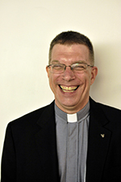
DEACON PHILIP GELIEBTER
I would say that my diaconal ministry is based on my vocation as a Third Order Franciscan. As Franciscans we follow St. Francis in prayer and action by striving to be peacemakers, working for social justice, and deepening our relationship with God. We share his concerns for the well-being of the earth, the poor, and the marginalized. I have worked with other denominations and with interfaith committees to try to follow Jesus’ call. My ministry at St. Mark’s Frankford is varied and includes everything from walking the streets as an outreach to bringing homeless families into our parish building and giving them temporary sanctuary until they obtain housing. At St Mark’s we work with many groups assisting the homeless and those suffering from addiction. This year I lived and worked for a week in Kensington at the St. Francis Inn which operates several ministries for the poor and disenfranchised. I am assisting in a project to help publicize the plight of persecuted Christians in Iraq as well as working with the Philadelphia Interfaith Walk for Peace and Reconciliation.
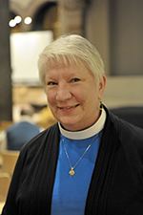
DEACON KAREN KAMINSKAS
Since my days in formation, I continue to grow into being a servant to God and to others, especially the older population. In my role as Deacon at Holy Trinity in West Chester, I provide pastoral care, especially to those in facilities, and to members of the West Chester community who attend the Friday Night Suppers. We have rekindled the Eucharistic Visitor ministry at Holy Trinity, with seven new Eucharistic Visitors being commissioned in November, 2015. I also serve on the Commission on Ministry and the Deacons’ Council. Outside the church, my ministry has extended to serving as a hospice and hospital chaplain from 2012 through 2015. Today, I am responsible for Pastoral Ministries at Maris Grove, a continuing care retirement community. Partnering with resident groups of all faith traditions to meet their religious, spiritual and bereavement needs has been a blessing. Of special interest to me is interfaith fellowship and education to encourage unity within the Maris Grove community, and to extend it outside that community.
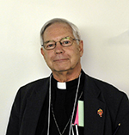
DEACON JAMES LEY
As Archdeacon of Chester, my main ministry is among the people of Chester, one of the poorest cities in the United States. I have worked with Chester Eastside Ministries for many years. Now that it has become Chester Eastside, Inc. I work with the other board members, Executive Director, staff and volunteers to offer many services: an after school program, a food ministry and an ongoing presence with the people of Chester. We are currently offering a library and computer lab at St. Paul’s in Chester. We work with clergy of other denominations and faiths to offer opportunities especially for young people. I also work at nearby Widener University, meeting with students, faculty, staff and board members to educate them about Chester and about the other cities in the U.S. whose people suffer from the dysfunction of a country that does not support its cities. Widener sends many students into Chester to work with people living in poverty. On Sundays, I travel with Bishop Michel to visit parishes.

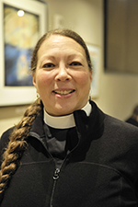
DEACON DONNA LIMA MONTEIRO
I serve at Grace Incarnation Church in Port Richmond where I teach Sunday School and work with the children as they learn to Acolyte. I lead a women’s group and help organize a monthly Saturday night meal. I regularly go with a group of parishioners to the St. Francis Inn and am seeking other opportunities for our members to serve in the world. I am a Chaplain at the Hospital of the University of Pennsylvania.

adfasd
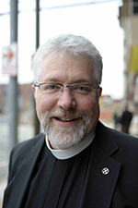
DEACON KEN McCASLIN
I am the Deacon Missioner in the Valley Forge Deanery, a very challenging ministry. My job is to bring the parishes in my deanery into ministry together. With the help of the Episcopal Community Services (ECS) and many others, we developed a town gathering that we called a Church Hall Gathering. As part of offertory at the Eucharist each parish presented their outreach programs. After the Eucharist, everyone gathered in the undercroft to begin the discussions on how the offering could be shared with other parishes to create a Deanery wide joint outreach. We have begun the development of a booklet that defines the outreach programs of each parish. We realized that outreach fell into three categories: Institutional (ECS, St. James school, etc), local community, and international. It is anticipated that a joint outreach will likely be Institutional or cross-county. The deanery deacons have provided great leadership in pulling all of this together.
asdasdf
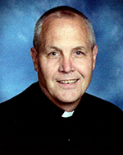
DEACON JEFF MORETZSOHN
Currently I serve at the Church of the Good Samaritan in Paoli, PA. Along with Sunday liturgical and sacramental responsibilities. My principal diaconal ministry includes the coordination and oversight of the Outreach Ministries and the associated volunteers. Among the current ministries there is the Good Samaritan Food Closet which distributes more than 200,000 pounds of food annually to more than 2,800 families. Operating every Thursday, the Food Closet is blessed with over 70 volunteers committed to serve those who are experiencing food insecurity and the associated disadvantages within the community. Related ministries include, Financial Counseling, HELPS Emergency Assistance, Good Works Home repair/improvement, Bridge of Hope mentor program, City Team Ministries. Additionally, I am a certified “Bridges Out of Poverty” instructor and a certified facilitator of the “Getting Ahead” curriculum published by the Aha! Process. I am committed to raising awareness, attention and energy to address the growing issues associated with income inequality, poverty, food insecurity and homelessness.
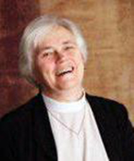
adfasd
DEACON MARJORIE OUGHTON
I was ordained in Oregon in 2009, and have been serving in the Diocese of Pennsylvania for two years at St. Paul’s, Chester. Among my other ministries at St. Paul’s I have helped put together an Evensong service for people serving others in Chester. This began as a service for first responders, but was expanded to include volunteers from Chester Eastside Ministries, St. Mary’s Food Pantry and eventually service volunteers from secular and faith-based organizations all over Chester. I am a Chaplain working at Holy Redeemer St. Joseph’s Manor in Abington. I am blessed with the opportunity to work with some of God’s oldest friends. I have recently completed a course in palliative care and look forward to working with the palliative care team. I am grateful to God, to the Church and to this diocese for the opportunity to serve.

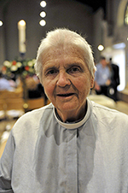
DEACON J. ROBIN ROBB
Pottstown is the third most violent municipality in the Common-wealth of Pennsylvania, and its poverty statistics equal those of North Philadelphia. As Episcopal Deacon for Social Justice, my ministry is to foster and develop the ecumenical response by “being present in the midst” of Pottstown‘s efforts to sustain a workable infrastructure to care for both the housed and un-housed poor. I cross boundaries to connect faith-based and secular factions so that we may work together. I co-chair The Committee for the Nameless. I help plan community-wide observances of holidays and commemorations. I walk the High Street circuit in solidarity with both Black and evangelical clergy as we pray for our people and our neighborhoods. I walk the High Street circuit with the poor and homeless who pass their days on the street. Despite the fact that they are not Episcopalians, I am their pastor. We nurture this relationship when they come to Christ Episcopal Church for the Monday community meal which is not a soup kitchen, but The Dining Room that is then extended into the afternoon as The Living Room.

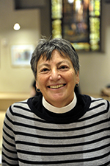
DEACON PAT RUBENSTEIN
I serve as deacon at St. Peter’s Church in Glenside. Outside the parish I have a ministry to children with special needs. During the week, I volunteer as a certified therapy dog handler, taking my Glen of Imaal terrier into the local school district to work with Emotional Support and Autism Support classrooms. My dog and I also go to Bucks County Courthouse when Children and Youth Court is in session to offer comfort and respite to children as they wait for their court hearings. We are among the special teams on call with the District Attorney’s office when child victims of crime need a friend as they await testifying in court.

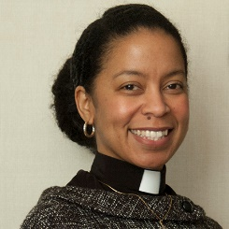
DEACON TONEH SMYTH
Toneh Smyth is a licensed social worker with a master’s degree in Health Service Administration. She has more than 13 years’ experience in the non-profit industry working with adults with mental disabilities and veterans. She has worked directly with shelters in Philadelphia to promote the integration of mental health and addiction services into housing initiatives for the homeless; and as a compliance analyst for a behavioral health insurance company under the Philadelphia Department of Health and Intellectual disAbility Services. Williams was born and raised in Brooklyn but has lived most of her life in Florida. In June 2017 she was ordained as a Deacon with the Episcopal Diocese of Pennsylvania and established a Veterans Ministry shortly thereafter. She currently serves as the Canon for Mission for the Episcopal Diocese of Pennsylvania.

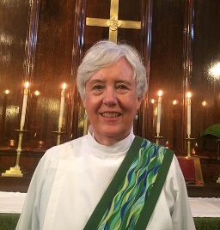
DEACON BARBARA TOBIN

I serve at St. Simon the Cyrenian Church at 22nd and Reed Streets in South Philadelphia (Point Breeze). We have a Fellowship Cafe two Saturdays a month, which is attended by mostly marginalized people who live in the community. Started a year ago by former Rector the Rev. Betsy Ivey, and Paul Jackson, a lay person, we serve lunch to over 100 people. Besides serving food, I have recruited volunteers to help, and I pray with guests who desire prayer. On those same Saturdays, I coordinate with St. Peter’s Food Cupboard staff who bring about 50 bags of groceries for neighborhood people who need food. At other times, I encounter many of our guests in the neighborhood and stop and chat. A few members of our parish and I also help support the Welcome Church on the Philadelphia Parkway (for those experiencing homelessness) about 6 times a year. We have a Communion service led by interfaith clergy and take sandwiches, desserts and beverages. I also volunteer weekly at Broad Street Ministry, a hospitality center for those experiencing homelessness or home insecurity in Center City.

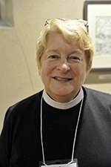
DEACON JOAN WYLIE
As deacon at Trinity, Coatesville, I have been working primarily with clients and staff of the Chester County Domestic Violence Center. After having recruited volunteers for the legal department of the DVC, I have been trying to develop an organized but flexible scheme to engage volunteers on call to accompany abused women to hearings in the county Court of Common Pleas. Volunteers are also needed to attend domestic violence hearings at District Courts and contact abused women there who don’t yet realize that there is shelter, counseling and legal help available. My work at Trinity includes cooking (and I do love cooking!) with parishioners for our two monthly meals for the community. One meal is for vets from the local VA hospital who are in treatment for PTSD and substance abuse, and the other is for anyone who drifts in. I cook, then I circulate and talk to our guests.

RETIRED AND NON-PAROCHIAL DEACONS:
Mrs. Dee Faison
Deacon Susann Fox
Deacon Rena Graves
Deacon Eleanor Greene
Deacon Dorothy Jessup
Deacon Carl Knapp
Deacon Elizabeth Kostic
Deacon Denise Leo
Deacon Robert Mellon
Deacon Cecily Anne Murray
Deacon Richard Newman
Deacon Judy Ray Parichy
Deacon Deborah Payson
Deacon Robert Ritchie
Deacon Robin Van Horn-Schwoyer

